GJJ SERIES

Operation instruction of high pressure homogenizer

CONTENTS

Sketch map A.B of complete machine
Sketch map A.B of pump body and valve body
1.Operating principle and purpose
2.Main technical index
3.Structure and trial operation of homogenizer
4.Installation and component of homogenizer
5.Use of homogenizer
6.Maintenance of homogenizer
7.Malfunction and serving of homogenizer

1

5

6
7

9
11

13
16
17

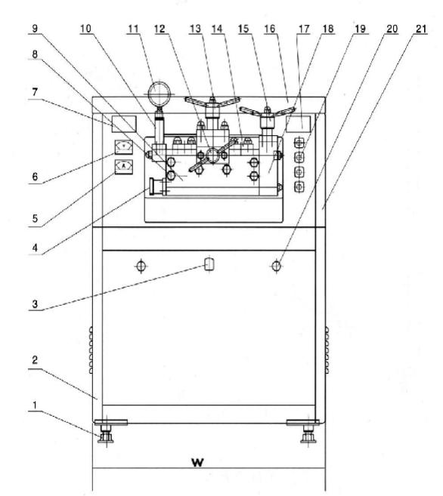

Diagram 1 Sketch map A of complete machine
1.foot 2.water 3.hand inlet 4. Feed inlet 5. Carrent meter 6.Voltmeter 7.nameplate 8.pump body nut 9.pump body 10.pressure transter cylinder 11.manomerter 12. High pressure hand body nut 13. Low pressure hand wheel 14.gland bush 15. Overflow valve hand wheel 16.upper cover 17.nameplate 18. Overflow valve hand wheel 19. Power switch 20.door lock of appliance chest 21.outer cover

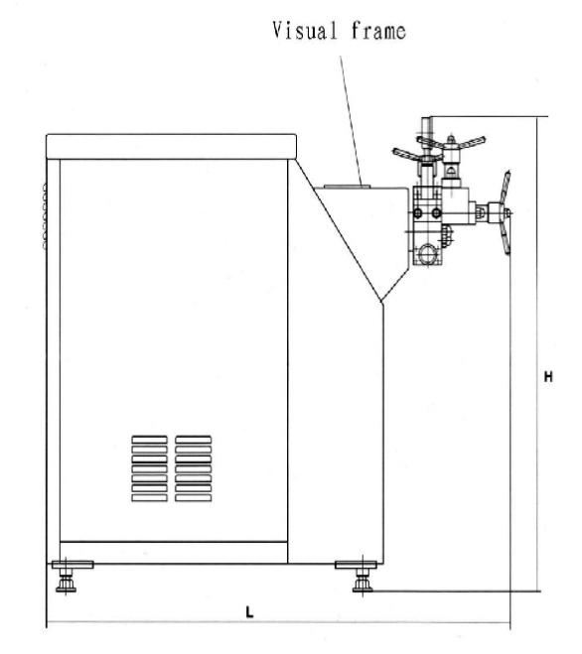

Diagram 1 Sketch map B of complete machine

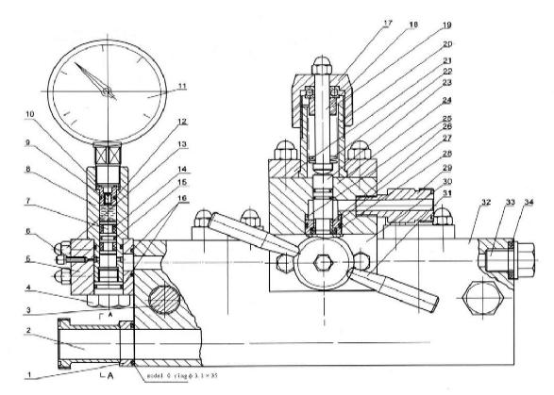

Diagram 2 Assemble drawing A of homogenizer head
1.connecting plate of feed inlet 2.concealed hinge of feed inlet 3. Tapped stud

4.plug screw 5.manometer seat 6. Vent screw 8.Pressure transfer cylinder 9.minute pass holt
11.manometer 12.model O ring 13.bolt nut

7.pressure transfer pison 10. Minute pass valve
14.model O damping ring

15.model O ring 16.model O ring 17.pressure adjusting nut 18. Pressure rod 19.bearing pedestal 20. Pressure adjusting seat 21.pressure pad 22. Butterfly spring strip 23.homogenizing rod 24.double-stage homogenizing valve body 25 impact ring 26.homogenizing valve 27.homogenizing valve seat 28.sealing washer 29.conceales hinge of dischange hole 30 pressure pad 31.handle
32 pump body 33.sealing washer

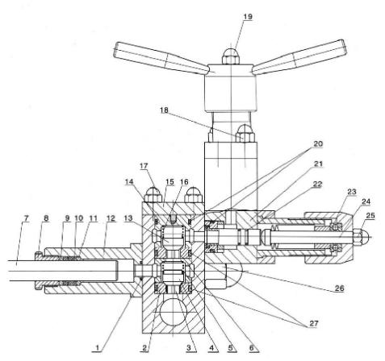

Diagram 2 Assemble drawing B of homogenizer head
1.model o ring ,sealing washer 2.lower valve seat 3.guiding rod 4.lower valve 5.lower valve sping 6.lower flangs 7.plunger 8.holding screw 9.chuck ring 10.plunger sealing washer (V type square type spacing block ) 11.locating sleeve
backing ring 12.plunger packing gland 13.upper valve 14.upper flange

15. Pressure pad 16.upper valve sping nut 20.model O ring ,sealing washer
22.homogenizing rod ,O type ring

17.bolt, nut 18.bolt nut 19.pressure rod 21.one-stage homogenizing valve body

23.planner bearing 24.pressure rod

25.pressure rod nut 26.pump body nut 27.sealing washer of upper and lower
valve

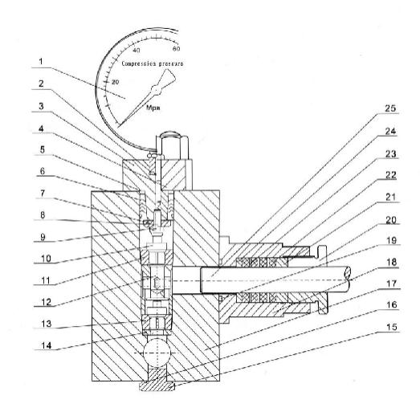
Diagram 2 Sketch map C of pump body

1.manometer components 2.gage stand gasket 3.gland bush of gage stand
4.gland bush 5.conic column 6. gland sealing packing 7.cage nut 8.adjusting Screwcage 9.cage nut with hole 10.conic valve core 11.upper conic valvseat 12.positing limit cover 13.lower conic valve seat 14.adjusting shim 15.plud screw

16.model O rubber sealing ring 17.pump body 19.sealling ring of pump surface 20.holding screw sealing washer(V type square type ) 23.spacing block

18.plunger packing gland 21.chuck ring 22.plunger

24.seat ring 25plunger

1.Operating principle and purpose
GJJ series high pressure homogenizer is a kind of superfine grind and emulsification equipment.It operates by utilizing suspension under high pressure condition and passes a com,comprehensive effect of
decompression ,Bulging ,explosion ,shear and high-speed impact in adjustable process of current limiting pressure.The granule and oil drop in the liquid are pulverized into very small size (dial 0.1-2um, <=1um on average )to form ideal emulsion and dispersed liquid.This process combines the functions of ultrasonic pulverize,colloid grinding,ball mill and jet.Products stability,consistency,mid character,absorbility,nutrition value,shelf life ,taste ,color and avidity can all be realized in the homogenization.
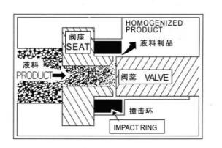
Diagram 3 Functional diagram
Main purposes:
1. This products is used for inclusion extraction form biologic cell or products creation.
2. Unsolvable two-phase materials )liquid-liquid or liquid-solid) are grindead into stable superfine emulsion and dispersive solution)

3. The refinement of other various materials.
In conclusion,the machine is widely used in the field such as food bio- engineering,chemicals and pharmaceuticals.

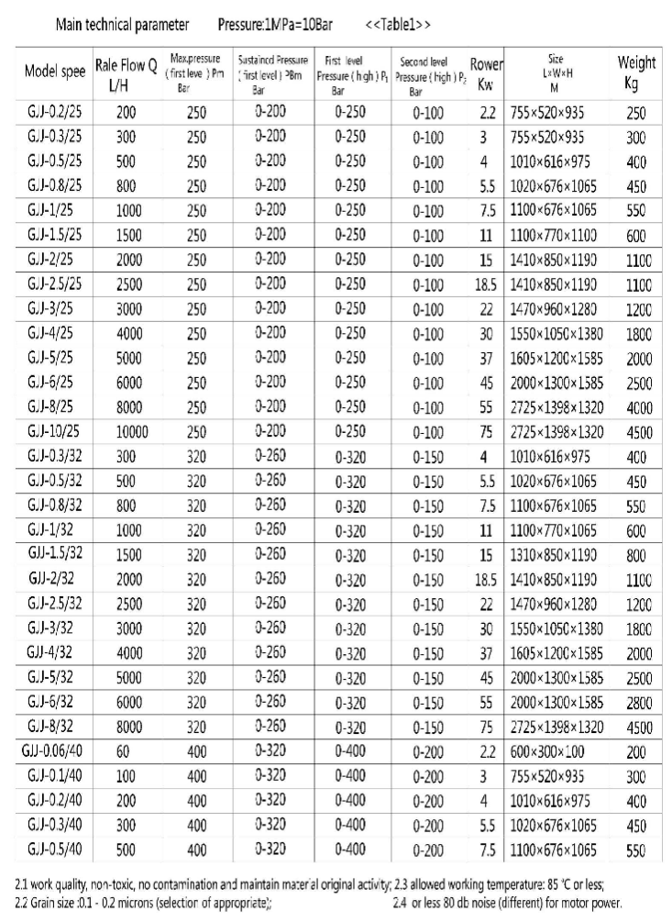

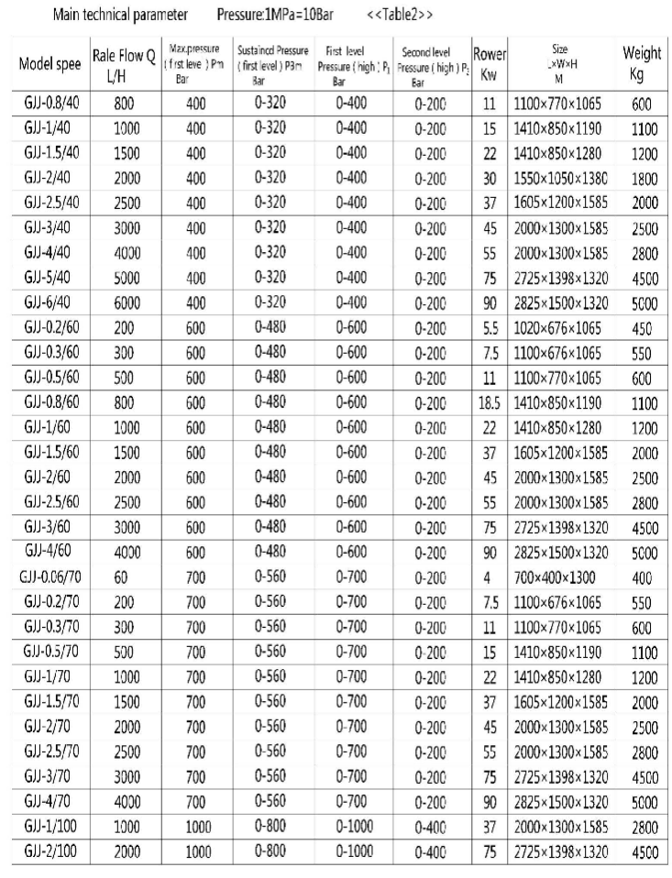

3.Main structure and component of homogenizer.
This machine is mainly made up of machinery base electromotor ,gear-box,high pressure pump and homogenizing parts.

3.1Machinery base and electromotor.
Machinery base made of V-iron with supporting funtion is the base of complete machine.Type Y3-phase asynchronous electromotor is installed on the top of this machinery base.Electromotor makes certain displacement on sideways to adjust the driving tensility of triangular adhesive tapes,Type Qvmagnetic starter is fixed and electric control box is equipped for high-power electromotor in order to protect the power network when starting the electromotor.

3.2Gear-box
Gear-box is features with two-level shift gears.First level adopts triangular adhesive tape driving to avoid unnecessary damage under special condition(over loading ).Second level adopts one or two level wheels driving Bent shaft driving can be done by level wheels connected to bent shaft.Bent shafe makes three or four plungers move straight back-and forth inside high pressure pump through connecting rod and slide block.Reciprocation of plunger can produce high pressure energy inside high pressure pump.
Standard rolling bearing and special type alloy materials are adopted in all parts of shift gears.Gear-box lubrication uses large gear wheel splashing to lubricants continuously various bearings and high pressure sealing element of plunger through oil hole.As plunger reciprocation can produce strong pressure intensity inside high pressure pump.High pressure sealing at the location of plunger reciprocates the precondition of strong pressure intensity.The high pressure sealing consists of plunger packing ,gland holding screw ,plunger locating sleeve,backing ring ,sealing washer and chunk ring etc.(See diagram 6).This series plunger sealing washer has two types .V type and square type.

3.3High pressure pump and homogenizing valve (Diagram 2-A.B)
High pressure pump is the heart of the machine and key part of grinding and emulsification .It is made of special high class corrosion resisting alloy material,including the following parts.

3.3.1Main pressure (Diagram 2-A)
Main pump is made up of 3 or 4 parallel-connected plunger pumps.It’s components include pump body ,upper and lower valve ,high and low pressure valve,gland bush ,upper and lower grange,and plunger etc.When plunger moves backwards,lower feed valve starts up to inhale operational feed liquid and

material.When plunger moves forwards.Lower valve shuts while pushing away upper valve.Operational feed liquid and material are compressed into the area of high pressure homogenizing valve.
3.3.2 Upper and lower valve,high and low pressure valve(Diagram 2-A.B) The upper and lower valve are made up of valve core and valve amount 3-plunger homogenizer has 6 sets with 3 sets respectively located on the top and underneath.They are all made from special type high hardness,high temperature resistant corrosion proof materials.The valve has the characteristics of simple design of structure,unique shape ,precise fitting ,convenient installation and dis- assembly.good service performance and long service life valve core and valve amount must be torn down for repair or replace by new ones when interface abrasion between valve core and valve amount occurs.When influx decreases or impulses and when the pointer of manometer or current meter flickers too much. Two levels of homogenizing valve
First level(high pressure )is the key part of superfine particulate grindinemulsification .When the compressed operational liquid with high energy enters the small hole of high pressure valve amount .The liquid is sealed tightly depending on high pressure valve core homogenizing rod spring and
Mandrell.The pressure of strong spring can be adjusted freely by and wheel .When operational liquid pressure intensity of plunger compression inside high pressure pump exceeds that of strong spring .The valve core is bounced away operational liquid will spurt out radially form valve mouth to strike the impact ring at extremely high energy and speed in order to produce various compound superfine grinding and emulsification which are stated in diagram 3.Then homogenizing valve from aging hole inside the valve body high pressure gasket and shaft seal cover are designed for the interface between the pump body ,valve body and hand wheel seat to bear high pressure sealing.
Second level low pressure homogenizing valve part.
It comprises such low pressure parts as valve amount.valve core,sealing
washer,shaft seal cover,hand wheel and etc.Operating principle is the same as that of first level high pressure homogenizing valve,mainly performing the function of emulsification,homogenizing valve mount and valve core will wear their interface after a long period of pressure deficiency and bad grinding effect.
First and second level homogenizing valve have its own characteristics and different operating requirement .It is necessary to choose diverse differential pressure .According to basic principles stated in diagram 3.the differential pressure between the two levels of the same material is larger.The grinding effect is better.As for most products.The formation of low pressure 5-10mpa<50-

100Bar>in second level valve can gather energy in first level homogenizing area to enhance well-proportioned grinding effect and at one time to minimize certain material condensation.,
The first and second level pressure must be chosen properly during production practice.Within the allowable technical index range ,granule can be grinded into thinnest pieces if choose second level pressure to a lower numerical in operating principle can be achieved on the basis of right technological tlirections and appropriate selection of machine model.
The installation of overflow valve can start up automatically to protect the machine in time of jerky or sudden pressure increase .Users must not optionally adjust the pressure index that has been set before leaving factory .Well- experienced users can personally adjust the pressure index which must be over PM index if operational pressure changes Otherwise,overflow valve is broken soon ,instead decreasing the rated flux.
3.3.3 Pressure display parts (Diagram 2-A)
This machine adopts shock resistant pressure meter that is installed on the top of gland bush by meter scat damping device when manometer runs at 3-plunger backwards and forward this installation can percent manometer oil leakage contacting food.This process is applicable for CIP Germ free operation.Don’t pull the interface between manometer and damping device otherwise oil leakage inside damping device occur manometer may be out of order due to exotericair. 4.Installation and trial operation
Operator should be familiar with working principle .Technical performance and functional connection between accessories using machine.
4.1 Installation
This machine can be placed on solid and horizontal ground without using bottom seat bolt there are several washers under the bottom beading point.Replacing rubber shock proof there soft pipe(SG79-75)or stainless steel pipe can be adopted to link inlet and outlet orifice of pump to other systems for instant observation of material inlet and outlet.Valve can not be installed on outlet or pipeline in order to avoid jerky operation and pipe blowout.Cooling water input is connected to intake pipe by polythene soft pipe(SG79-75)according to users requirements.The influx control of cooling water can be realized by switch.The rotary direction of strap wheel must be clockwise <Anticlockwise of hand wheel).Make sure that rotary direction must conform to the arrow head direction of nameplate on outer cover in order to guarantee full lubrication of all driving parts.If large stringent can not rotate ,according to the direction of nameplate arrow on outer cover ,exchange connect two wires of 3-phase electrical source.

4.2Grease
Wheel box is not lubricated ,when this machine leave factory ,High quality industrial lubricant such as gear oil (Mobil gear 600)or machine oil of China product N68(GB443-84)is chosen before trial operation.Choose machine oil HJ50 at the location of high temperature .Oil quantity must not exceed the required level or middle of oil mark (half content).or machine can not be started up.

4.3 Trail operation
After installation ,wiring or maintenance ,trial operation is necessary to check.:(1)if wire is correctly,connected .(2)if machine can run normally ,Processes are as follows (see diagram 1.2).
4.3.1 Loosen high pressure hand wheel.(diagram 1-12) and low pressure hand wheel diagram 1-13 anti-clockwise a little bit,and loosen screw cap on two hand wheels clockwise(diagram2-19-25)
4.3.2 Let cooling water enter the machine slowly from water inlet joint to ensure that no water is on box bottom.Dry attrition between plunger and sealing ring inside steel cover can be avoided.
4.3.3 Start up the joint of feed inlet pine.Use water instead of material while conducting trial operation.
4.3.4 Turn start wheel several circles by hands before rial operation to ensure plunger reciprocation is normal with no impact phenomena.
4.3.5 Start-up press the starting up button (green color)to run for 5 minutes under no pressure and get all parts lubricated .At the same time ensure that pump body is fully fed by materials and exhaust air inside (diagram 1-9).Discharge pine joint can discharge materials normally with on impulse phenomena ,Loosen vent stop give out air inside feed pipes and pump body for models less than 25Mpa,1500L/H.
When feed liquid flows normally from exhaust pipe.Vent screw must be screwed down.
4.3.6 Pressurizing,exam the pressure according to pressure allowed by technical index pm,p1,p2 and the model and specification on machine
nameplate .Methods:Screw down slowly the low pressure hand wheel clockwise(diagram 1-12)to see turn carefully the high pressure hand wheel

clockwise to see manometer indicating p1 until reaching the max operational pressure pm makes on nameplate.
The indication of machine normal operation:
(1)stable pressure -----manometer pointer can away when hand wheel runs.
(2)Enough flux---------material discharge per minute can reach the rates flux in nameplates .The flux can be got by regular sampling .weighting and conversion.
(3)The machine can regularly start using when there is no exceptional noise.
4.3.7 Pay frequent affection to each bearing temperature increase of oil tank.Operational noise and pressure change,

4.3.8 Machine termination
When operation is over loosen high and low pressure hand wheel anti-clockwise successively (diagram 1-12)to ensure manometer pointer indicating zero.Wash by filling water or stop the machine.
Use of homogenizer
5.1 The size of materials should be chosen by 0 <20um.Filter net of 6080eyes can be used for roughly-processed materials,which enter pump body to prevent big granules from causing manometer pointer away too much.
5.2 Feed liquid usually flows automatically into pump body at high position (the relative height between feed inlet and surface of charging basket must be over one meter)use the pressure input of low pressure centrifugal pump to avoid partial vacuum,air inhalation body ,unstable pressure noise and vibration inside pump body when feed liquid is over ropy with bad liquidity or charging basket location is too low.

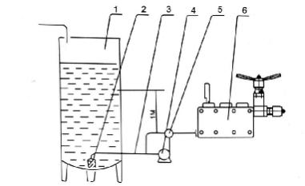
Diagram 4 Connecting sketch map of pump body and material buchet

1.charging basket 2.filer-net 3.pipeline 4.low pressure centrifugal pump

5.reversal ,valve 6.pump body

5.3 Non-level pressure adjusting model
Fix on duration operating pressure P according to the technical requirements of different materials.Low pressure index is needed to reach best grinding and emulsification effect.And continual production requires0.5-10Pa(100Bar)for second level low pressure P2 and P1<0.8pm for first level high pressure .The machine can run by light load thus saving energy and increase service life of parts.Frequent replacement and repair of fragile part and sealing element are avoided so as to reduce production costs.
Homogenizer grinding effect is subject to following factors.
A granule hardness and thickness :B ,most operating pressure is key
factor.Grinded granule will be thinnest when high and low differential pressure of P1-P2 is larger.Homogenizer of type Pm=70Mpa(700BAR)is applicable for coffee coca soybean,peanut,coca nut,almond,walnut and lotus seed .For pure fruits and dairy products,choose type of Pm=40Mpa(400bar)and Pm=25Mpa(250bar).Best operating pressure is decided after the repeater trial sampling (includes adding or subtracting stabilizer proportion)by professional during production.The minimal disposal quantity for experimental homogenizer is 500ML.
Some materials must be homogenized over twice to reach satisfactory effect of 0.1-2um.Residue-free materials such as soy milk and peanut milk must be homogenizer three times successively .While fine chemicals,daily

chemical,pharmaceuticals and bio-engineering products usually homogenized many times.
5.4 Control feed temperature below 85C,otherwise it may cause material falsification effecting manometer pointer swaying to much inside pump body and deficient material discharging.Gas explosion may seriously happen to cause gland bush distortion,bolt broken and manometer damage .Cool down pump surface with cooling water when temperature cannot be controlled below when homogenizer pressure reaches Pm=70Mpa (700Bar).Feed liquid will increase temperature about 15 degrees per time .
5.5 Conduct production operation according to the order of 4.3.1-2-3-5-6-7.Run the pump body under no pressure for about 10 minutes by detergent or water before shutting machine.
Here are general cleaning methods of dairy products for your reference
A. hot water (80C-90C)washing.
B. 1.5% citric acid solution (use for eliminating protein gelatin)
C. 1.5% causticity solution (used for neutralizing acid lotion)
D. Hot water (80-90C)washing (sanitize with hot water before using)
This machine is applicable for the production of foodstuff ,pharmaceutical and skin purifying cream etc.
All sanitary regulations must be complied with and correct washing and sanitizing procedures must be conducted before and after production.

5.6Points for attention
(1)Don’t run machine with no feed liquid or water inside pump body :
(2)Don’t run machine before starting up plunger closing water valve:
(3)Don\t run machine if lubricating oil goes bad or does not reach the required position.Low oil level may damage crank:
(4)Do not start up machine under pressure.Loosen homogenizing valve handles after every termination of medicines.
(5)Inner lubrication is done crank or gear wheel with oil.Do not operate reversely
(6)Be familiar with operation instructions before operating and maintenance:
(7)Check to ensure screw and screw cap do not loosen before using new machine:
(8)Shock-proof manometer and special manometer seat are adopted in this machine,when manometer occur malfunction during normal machine

operation.check if there is no oil inside manometer seat,feed with cooling oil or glycerin:
(9)Stop machine right away to check if manometer pointer does not react when pressuring with hand wheel:(see diagram2)
A:Tear down manometer ,take M6 minute pass bolt our of minute pass valve,or take out minute pass valve by M8 screw push pressure transfer piston indies pressure transfer cylinder to lower bottom with round pole(4mm)or chopsticks fill the cylinder with cooking oil and the put minute pass valve or M6 minute pass bolt into valve seat.(do not screw down)add slightly some cooking oil to install manometer(sealing washer (type14*2.4)must be installed.
B:While replacing new manometer ,fill the small hole under manometer with cooking oil by an inject or other tools.The rest of operation prorating procedures is the same as part(A) .After relating new manometer,start up machine to pressurize then stop.repeat method A one or two times until manometer is fully filled with oil.
C.If the manometer pointer can not return to zero position,loosen the manometer then screw down it again.
The appliance control box of this machine is equipped with overload protector.
The machine can stop automatically if pressure exceeds the most interracial operating pressure Pm stated on nameplate.According to local power supply-well- experienced electrician should adjust overload protector accordingly in time trial operation.
Current meter must be installed while operating homogenizer. Because of relevancy between pressure and current,manometer components are easily damaged due to careless handing during production practice.However current meter is comparatively durable if only it is not soaked with water.As a
result ,operator should mark down current numerical value corresponding to production pressure while operating new machine in order to monitor simultaneously by two meters.Manometer can be dismantled when it is out of order or damaged.It is on the safe side that gland bush hole is sealed with bolt(M20*1.5)and monitored by current meter.Spare manometer components are used to regularly adjust current meter, for instance ,adjusting once every month.Wheel box can be lubricated automatically and engine oil must be filtered

with filter-net(over 150eyes)to ensure the cleanness of oil.Replace the new machine with engine oil that can be repeatedly used after deposition filtration.

6.Maintenance
6.1 Lubricating oil must be replaced when it has operated for 750 hours or its color turns into ivory-white.Loosen oil outlet screw cap installed in gear-box,let out waste oil (which is placed in oil can and upper clean oil is useful after deposition)with plastic pipe.screw down oil outlet screw cap.Washing must be done with diesel oil in gear case under zero pressure after running machine for 5 minutes until all driving parts are completely cleaned,and then exhaust diesel oil and inject flesh lubricating oil.
6.2 Screw down driving fastener and flap driving strap if exceptional nose occurs after a period of operation.(see diagram 7.6 for methods)
6.3 All sealing elements and valve inside pump can be easily damaged.Normal maintaining rang includes manometer pointer swaying too much,deficient or impulse influx,low pressure ,bad grinding effect and etc.,Maintenance man needs to check or repair regularly(see diagram 7.2-5 for methods)
6.4 Inner bearing of electric machinery is lubricated with butter during installation by manufacturer.Maintenance can be carried out according to general maintenance regulations of electric machinery,
7 Malfunction and servicing
7.1 If machine can not start up,check the power parts of circuits including contact ,switch ,fuse and relay etc to eliminate failure stage by stage.

7.2 Leakage
7.2.1 Plunger leakage:Automatic sealing device is adopted in this machine(diagram 5).Do not screw down hold bolt if only plunger dose not leak.When leakage is found.screw slightly the holding bolt after stopping the machine until leakage is over.Replace the old sealing washer with new one if sealing function is out of surface causing leakage,the worn plunger mus be replaced.

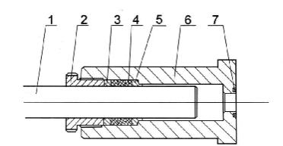
Diagram 5 Sketch map of plunger sealing

1.plunger 2.holding bolt 3.chuck ring 4.plunger sealing washer(V type or
square type ) 5.locating sleeve,backing ring 6.plunger packing gland

7.Sealing washer
It is especially pointed that square sealing washer may expand when touching water and install holding bolt(diagram5-2)with hands instead of spanner.Small leakage occurs at the beginning of operation ,do not screw down by 60 degrees .Leakage happens again after 30 minutes,the holding bolt must be screwed down by 60 degrees.Leakage does not change within 30minutes.
Screw again by 60 degrees.If leakage decreases,stop screw down the holding bolt and leakage will increase naturally.
7.2.2 Leakage between pump body and wheel box can be sorted out by screwing pump body net with spanner (diagram 2-26)

7.2.3 Leakage between pump body and valve body
Discharge high and low pressure ,screw down two hex-angular nuts on high pressure hand wheel seat until leakage does not occur.Otherwise ,replace high pressure sealing washer (diagram 2-20).Pay attention to the gap parallelism between pump body and valve body.

7.2.4 Leakage between pump body and gland bush
(1)GJJ series adopts axial surface sealing (mainly for medium and low pressure homogenizer).Discharge high and low pressure ,screw down four hex-angular nuts on gland bush 14 until leakage does not occur.Otherwise,replace high pressure sealing washer.Pay attention to the gap parallelism between pump body and valve(same as the above)

(2)GJJ series adopts redial automatic sealing that is on the safe side.When components leaks after being disassembled many times,check if gap c exists between seat ring and gland bush of components.increase seat ring surface 2- 5mm.
Gland bush V shape sealing components assembly:
Check to ensure column surface is galled without nick .The lower surface of V shape sealing components is 1-1.5mm higher than of conic column(diagram 6).Cage nut must be screw down with spanner under the lower surface of conic column instead of sealing components.spacing column functions as controlling the starting up height of upper conic valve core which is about A:2.5-3mm.
Gland bush and sealing components are installed inside pump body leaving gap of C:5mm between gland bush and sealing components.Install 4.5mm thick shim at the gap of C:5mm ,press it into pump body hole , loosen bolt M12 on gland bush when gland bush does not touch pump body (about 1-2mm),and then take out shim press gland bush tightly.
Annotations:
Gland bush adopts the format of taper hole V shape sealing ,its characteristics includes safe sealing ,long service life .Here are discharging methods.
(1)Loosen gland bush nut to half position,input water to start up
homogenizer,pressurizing by 5Mpa(50Bar),all parts of gland bush go up ,and then tear the nut.
(2)Loosen bolt M12 between two nuts of gland bush 5mm, unclean gland bush with tummy bar large opener and dis-assembly is done.

Wrench screw to face under the cone column,and must not and sealing components of end face flat, because the seal assembly stress to rise,after the lock nut loose doesn’t work.Round up the height of the cone valve core rising open on the limit ,general control in A:around 2.5 3 mm,if the lock nut loose,limit on

column and taper valve core of bay is not appropriate,serious when the cone can not open or broken .
Capping and sealing components into the pump body,because the gland seal assembly after the stress along the conical cylinder moves up ,enlarge the diameter components,cylinder diameter and clasped cone ,have the effect of the radial seal.When assembly so it is important to note that capping and sealing components C seat ring should be :5mm.Capping and sealing components into the pump body should be in C :5 mm space on 4.5 mm thick process gasket,and then gently pressure into the pump body hole,such as gland has not yet run into the pump body(about 1-2 mm),loosen the M12above the gland bolts ,remove process gasket,compression gland again.Table gland are basically the same ,but should be put first V-shaped sealing components by hand or vise pressure,like apace gap(figure 6).Prevent seal assembly when loaded
Into the hole because of cooperate,along the conical conical column up, outer diameter amplifier,hole to cooperate more tightly,although finally into,but has 5mm gap does not exist,so the influence of gland seal performance and life .Gland nut does not need to tighten,the sealing effect is also very good.
Note:gland cone hole Veal form,the advantages of reliable,long service life,pay attention to the remove method has two kinds:
(1)loosen the gland nut in half,and then start the homogenizer,the water pressure of 5mpa(50bar),gland on the top of the complete set immediately,and then go to the gland nut screw,can be removed.
(2)The twist to the gland nut,screw Song Ya cover M12 screw nut between 5 mm ,with a lever or with a screw river to pry inhaler cover can be removed, the pressure gauge of gland ,after down gland nut with lever directly or with a screw diver can be removed

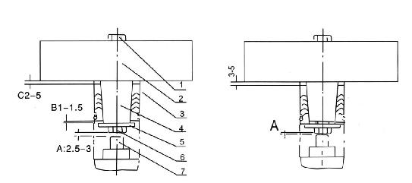

<a> correct <b> incorrect
Diagram 6 Gland bush A of pump body

a. Method for replacing V shape square sealing components:
After tearing down big nut<diagram 1-16 >and pump body<diagram 1-9 >.the plunger sealing cover <diagram 5-6 >of sealing components can be taken out from machine body.Draw out plunger<diagram 5-1 >.screw out holding bolt <diagram 5-2 >.and then push out V shape or square type chuck ring <diagram5-
3-4>
Assemble anti-clockwise for replacement
b.Method for replacing V shape square sealing components:
Square sealing components are made up of high-pressure molding sealing ring and segregating ring one segregating ring is installed after One or two sealing ring
First clean plunger sealing cover.install gasket of square spacing cover inside the cover press every square sealing component into the cover And then install chuck ring that must exceed cutting though install holding bolt Put cooking all on outside of plunger which can be inserted slowly square sealing components After the replacement of plunger sealing complete machine can installed.

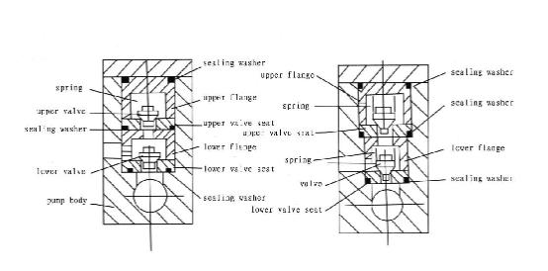
Diagram 6 structure drawing of pump valve 7.3 Inner leakage

7.3.1 Deficient influx with pressure:
There may be a jam of filter-net hole or pipeline at feed inlet that causes deficient material inhalation ,even no influx,no pressure and on indication of manometer Eliminating methods:Clean out filter-net hole or pipeline jam <outer filter-net installation will be much better at user option .

7.3.2 Enough influx with no pressure:
Severe wearing between high press valve core and valve seat can cause deficient high pressure ；while deficient low pressure may be due to severe wearing between low pressure valve core and valve seat can be repaired on surface grinded with grinding material<200#green carborundum>after being repaired on valve seat .IN addition .Too much hand wheel reverse rotation when giving out high pressure may cause deficient pressure .the solution is to cut distorted parts with knife .well-experienced repairman grinds high pressure seat repeatedly during operation until bulge is grinded plane .when annular groove inside impact ring reaches depth of ism.Grind high pressure valve seat a bit,lower or install impact ring reaches depth of ism ,grind high pressure valve seat belt,lower or install impact ring reaches depth of ism,grind high pressure valve seat a bit lower or install impact by adjusting direction after dis-assembly.

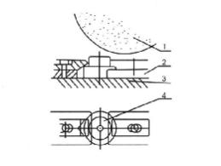
Diagram 7 Grinding of high and low pressure valve seat 1.grinding wheel 2.clamp 3. Magnetic copula 4. High pressure
< low pressure >valve seat

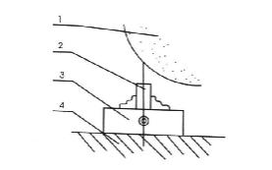
Diagram 8 Grinding of high pressure valve core
1.grinding wheel 2.high and low pressure valve corn 3.clamp< 3-foot chuck > 4. magnetic cutups

7.3.3 Deficient influx
Pulse material discharging is <1 >due to the low tightness of one valve .Grind the valve surface again or replace with new valve if valve surface has been worn. Knock valve seat out of pump body with pole,grind by putting grinding material<200#green carborundum >on the interface between valve core and valve seat.valve core triangular and surface must be installed fully inside valve seat,otherwise the leakage of conic valve component sinner face will be possible.

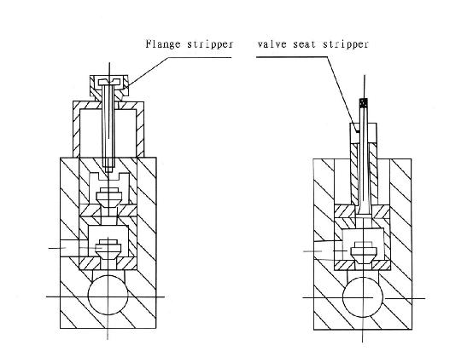
Diagram 9 Sketch map of valve and flange disassemble Dis-assembly methods for valve flange:
1.First disassemble pressure pad<diagram 2-15>,and then take out upper flange with disassembling tool or screwdriver<diagram2-14>
2.Take out upper valve<diagram2-13>.and its spring <diagram2-16 >with hands or hand clamp.and then take out upper valve seat with valve seat with valve seat disassembling tool.

3.Take out lower flange with valve seat disassembling tool<diagran2-6>

4.Take out lower valve<diagram2-4 >and its spring <diagram2-5 >with hand clamp.
5.After washing and replacing valve,install it by this order from lower part to upper part.Do not mix valve and valve seat.

<2 >strike valve seat tightly with large force when installing conic valve,otherwise inner leakage may occur to damage pump body inner hole that must be repaired.
<3 >when three lower conic valve seats adheres to valve cores,take down three bolts under pump body <diagram 10-7 >and poke upwards with opener
Small pulsation influx is due to the outer leakage of pump plunger sealing or sealing between pump body and chest .solve this problem according to method
7.2 .leakage occurs at the interface between pump inner hole and one or several valve seats of six conic valves inside pump body .thin down the adjusting gasket under lower conic valve seat and spacing cover under upper conic valve in order to ensure underside 0.5mm gap <diagram 11,12>and strike tightly with striking pole <diagram11,12-8>
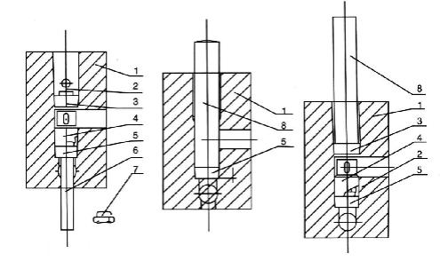
Diagram 10 Sketch map of conic valve dis assembly Diagram 10-12 Sketch map of conic valve installation
1.Pump body 2 .conic valve core 3.upper conic valve seat 4.spacing cover 5.lower conic valve seat 6.striking pole <accessory 4 > 7.plug screw 8.striking pole<accessory 3>

Points for attention :(1)Keep the staring up height of upper valve core about 2.5~3mm,3mm for lower valve core ；（ 2）The serial number of valve core and valve seat must not be installed by error. 7.4 Abnormal pressure indication is caused by incorrect operation besides the above-mentioned reasons.The pointer of manometer and current meter flickers too much.
Reasons:<1 >Machine is not fixed on a flat ground and vibrates during operation.(current meters indicated normally.);<2 >Feed temperature is high over 85℃； <3 >Feed pipeline is not unobstructed and mingled with gas ;<4 >Feed granules very thick with uneven thickness;<5 >Agglomeration of dense feed liquid block the pipeline inside manometer seat. This may happen in the production of soy milk ,asylum and plastics;<6 >High pressure spring inside hand wheel seat is pressed tightly by people;<7 >The careless pulling on manometer can cause the leakage of damper top and deficient inner damp;<8 >The machine runs under pressure limit and manometer has been damaged. The manometer point does not turn when pressure goes up as to instances do <5 >and <6 >.On the other hand .Its sudden movement can even damage the pointer.
Solution:1.Be familiar with operation instructions of homogenizer;2.Loosen screw cap on hand wheel clockwise in solving failure <6 >,and them loosen high pressure spring ;3.For failure<5 >.manometer may be replaced by current meter for monitoring .Seal gland bush screw hole with bolt(M20X1.5).The manometer can be used for regular collation)usually every one month );4.As for <7 >and<8 >disassemble manometer .input organic silicon oil or replace manometer components. 7.5 The engine oil inside wheel box is easily emulsified or led into flume by connecting rod lower the influx of cooling water and ensure there is no water in flume .Check and replace rubber sealing ring of connecting rod and its spring oil is led into flume by connecting rod. 7.6 The slowdown of plunger linear velocity or the skidding of driving strap when pressure goes up is due to too flabby driving strap.Tear down back board of lower cover,and screw down the cage bolt on base of electrical machinery.

Table 3 Removal methods of general malfunctions

NO Malfunction contents | General reasons | Removal methods
1 Flow is deficient and pressure  cannot reach a high level | Valve is damaged with leakage.Sealing parts are damaged.Homogenizing valve is damaged with leakage. | Check,repair and replace.
2The manometer pincer flickers too much. | Valve is damaged with leakage.Sealing parts are damaged.  Module of pressure meter is not in good condition. | The same as the above
running sound is  3Valve uneven much.  .Pressure fluctuate too | Part of valve is damaged with leakage. | The same as the above
4 There is leakage at the Plunger. | Plunger sealing washer is worn. | Replace the damaged sealing ring with new one.
5 Shock sound exist inside the pump body. | Plunger abrasion  Gas exists inside pump  Impurity exists inside pump | Use deflating bolt Dissemble and check.
6 Beating sound exists inside the wheel box | Bush or shaft bushing of connecting rod bolt is flexible. Upper valve is damaged with leakage. | Replace  Screw down  Examine and repair
7 Bent shaft bearing gears hot. | Bearing is damaged.  Impurity exists inside the bearing  Bearing is not well installed. | Replace  Check,wash  Re-install
8 Sliding block get hot. | Impurity exists on interface | Disassemble,check and wash
 | Between sliding block AND CHEST.
 | Lubricate aperture is blocked.
9Electromotor gets hot. | Appliance is broken.  Indoor temperature is too high | Cheek,repair  Take measures to low the  temperature.

28

29

30

